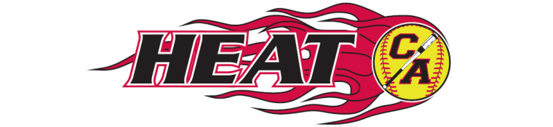

Cooper Armstrong Girls Fastpitch Association Meeting Minutes
Sunday July 23, 2017
7 pm Frankies Pizza New Hope

- Call to Order/Attendance: 7:04pm – Kevin, Carrie, Cherry, Tammy, Eric, Erin, Tia Guest: Kristine Erickson
- Reading/Approval of minutes from previous meeting Kevin motions to approve. Carrie 2nds. All approved.
- Open forum
- Treasurer’s Report – Cherry
  - Account balances
    - Main account $2,689.10
    - Fundraising account $8,892.92
    - Savings account $751.02
    - Total $12,333.04
- President’s Report – Kevin
  - Fall ball
    - Current registration 60 currently registered (a few more possibly expected)
      - 8u 1
      - 10u 1
      - 12u 1
      - 14u 2
      - 16u possibly combine with 18U
      - 18u
    - League meeting Aug 10
      - Deadline to register and pay for teams
    - Fall ball dates (proposed)
      - Combined practices July 31, Aug 1-3
      - Team formation Aug 4-5
      - Fall ball coaches clinic and coaches meeting Aug 6
      - Kick off event Aug 13
Cherry motions to tie blankets kits for a community service project for Fall teams to tie at Kick-off event. (2xteam) Carrie 2nd. All approved
      - Catchers clinic
      - Fall ball hitting clinics (previously approved)
      - Fall ball pitching clinics/practices
        - Propose 6 weeks (Aug 5, 12, 19, 26; Sept 9, 16)
        - Propose cost of $60
Carrie motions to approve the proposed cost of $60 for 6 weeks pitching clinics, but to add 2 additional dates for live pitching, open to signed up pitching/catching/hitting players. Cherry 2nds. All Approved.
  - Upcoming board elections
    - Positions up for election in August are president, secretary, publicity, fundraising and apparel
    - Currently vacant position is treasurer Kristine E. interested in this position, will discuss details with Cherry
- Vice-President’s Report – Erin
  - Fall ball practice fields
- Director of Fundraising
  - Heggies
    - Follow up on summer round two Send follow-up email to turn in order forms
    - Fall ball Heggies
      - Aug 13-26 sales period
      - Sept 14 delivery
- Director of Apparel – Tammy
  - Fall ball shirts (and coaches shirts)
  - Deadline to order?
- Director of Publicity – Dave (not present)
  - Whiz Bang Days parade Went well. Suggest to have more candy and squirt guns
- Equipment Manager – Eric
  - Summer equipment return
  - Fall ball equipment distribution Same day return/distribution
  - Anything needed for fall ball? Will order more ice packs and freshen up first aid kits
- Player Representative – Carrie
  - Player survey Almost complete
- Open Discussion Looking into possibly setting up an equipment exchange
- Open Action Items

Cherry motions to adjourn @ 9:41pm. Erin seconds. Approved.

Subsequent email vote on 08/14/17:

The motion is: to add three (3) additional hours of Amy's time, on Aug 19, 26 and optionally Sept 9 (depending on participation levels the first 2 weeks), to occur at 11am each of those dates (right after scheduled 10am pitching clinics). This would be free to participants.
MOTION APPROVED

