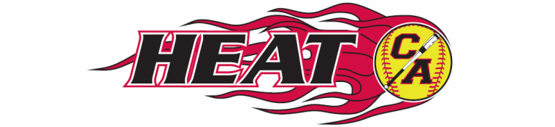

Cooper Armstrong Girls Fastpitch Association Agenda
Sunday May 21, 2017
8 pm Frankies Pizza New Hope

- Call to Order/Attendance: Kevin, Carrie, Eric, Tia, Erin, Dave & Tammy
- Reading/Approval of minutes from previous meeting Kevin motions to approve Aril minutes. Carrie 2nds. All Approved.
- Open forum
- Treasurer’s Report – Cherry (not present, update sent via email)
  - Account balances
    - Main account $11,183.59
    - Fundraising account $4,509.92
    - Savings account $750.98
    - Total $16,444.49
- President’s Report – Kevin
  - Summer update
  - Team rosters – www.josoftball.com
    - All rosters entered and approved 8u -14u
    - In process of collecting birth certificates
  - Tournaments
  - Spring hitting clinics
    - Extended gym time 2018 Something to consider, and have 1 round of hitting clinics complete
  - Spring pitching clinics
    - Makeup dates are May 27 at 11am and May 29 at 9am
    - Amy is willing to do additional make up sessions in Bloomington
  - Conditioning clinics
  - Upcoming board elections
    - Odd year openings are president, secretary, publicity, fundraising and apparel
    - Even year openings are vice president, treasurer, equipment manager and player representative
    - recruit this summer – talk to team parents
  - Fall ball
    - Proposed rates
      - 8u - $50
      - 10u - $75
      - 12u, 14u, 16u, 18u - $125
Kevin motions to approve above Fall Ball rates. Eric 2nds. All approved

Carrie motions for CAGFA to provide discount incentive to players who refer an 8/10U (non-sibling) player for Fall Ball to CA Heat. $10/referral towards Summer registration. Up to $50.00/player. Dave 2nds. All Approved.
    - Fall ball hitting clinics Kevin motions CAGFA to provide 1 hr/team hitting clinic with Mandy. Dave 2nds. All Approved.
    - Fall ball coaches clinic
    - End of school flyer Higher rate then previous flyer distribution
Kevin motions we send out flyers to elementary 1st-5th grade girls. B&W on color. Carrie 2nds. All Approved.
    - Open registration June 1, close July 15 or so
    - Team formation
  - Dome ball
    - Fall (Nov-Dec)
    - Winter (Jan-Feb)
  - Refund policy Dave motions to add disclaimer. Erin 2nds. All Approved.
- Vice-President’s Report – Erin
  - Field improvements Erin has reached out to appropriate fields regarding improvements/opportunities
- Director of Fundraising
  - Heggies
    - Round one – 8u, 10u and 12u
      - Orders have been collected
      - Delivery Thursday June 8 4:30 pm
      - Results?
    - Round two – 14u A & B, 16u, 18u
      - Selling period first two weeks of June
      - Delivery early July
      - Team visits
- Director of Apparel – Tammy Hats have arrived. $25.00/each = 20 hats. 2/team Possibly order more hats
- Director of Publicity – Dave
  - Website calendar and team calendars
Dave to follow-up with Cherry re: details for Whiz Bang Days parade. Truck & parent volunteers still needed.
Dave will send mass email to All regarding social media links.
- Equipment Manager – Eric All equipment has been dispensed to teams. Additional equipment will need to be ordered as we grow. Maxed out currently. Eric recommends purchasing a generator. Would provide teams better opportunity to use pitching machines. Will look into cost.
- Player Representative – Carrie
- Open Discussion
- Open Action Items

Dave motions to adjourn @ 10:46. Erin seconds. Approved.

Subsequent email vote on 06/13/17:

The motion is: To proceed with ordering 1000 of the customized 2 inch by 0.71 inch pins for Nationals @ $1.67/each, in either Option A or Option B. Board approves: Qty 1000 – Option B.

June 18th, meeting canceled. Next scheduled meeting on July 23, 2017 @ 7pm Frankie’s. Board has agreed to cover any items via email vote that cannot wait until November meeting.
Currently no votes taken.

